 **GO-STANDARD NURSERY & PRI-SCHOOL**

**MID OF YEAR EXAMINATION 2023**

**BABY CLASS: (3 – 4 YEARS)**

**LEARNING AREA 4: MATHEMATICAL CONCEPTS**

**My name is: ……………………………………………………………….**

**My School is: …………………………………….………………………..**

**I am in: ………………………………..…………………………….…………………..**

I. **Copy and draw the shapes.**

_________________

__________________

___________________

_____________________

2. **Count and write.**

=_______ =_______

=_______ =_______

= ________

= ______ = ______

3. **Count and match**.

 5

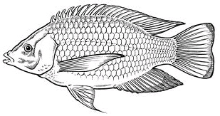

2

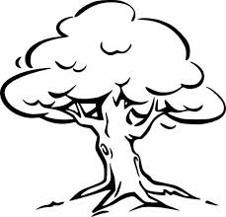

4

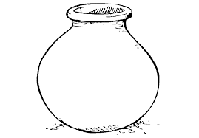

3

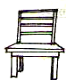

1

4. **Count and circle.**

= 4 3 2

= 1 7 5

= 9 8 6



= 3 4 5

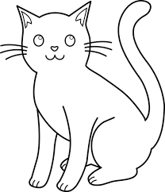

= 1 3 2

**END**